**Python Training – Mid Assessment Test**

**Created by Ankur Saxena**

**Date – 01/02/2023**

**Question 1**

**What is an abstract class?**

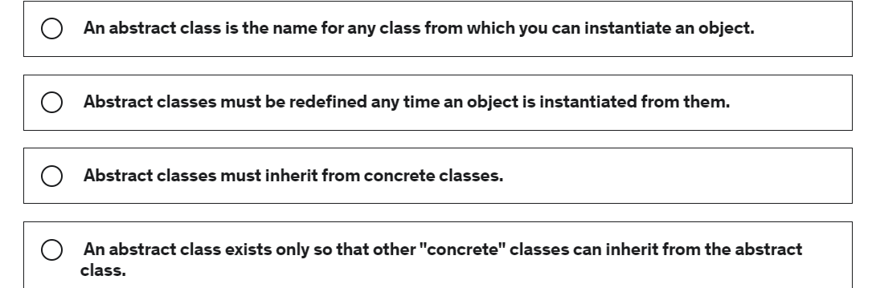

**Question 2**

**What happens when you use the build-in function any() on a list?**

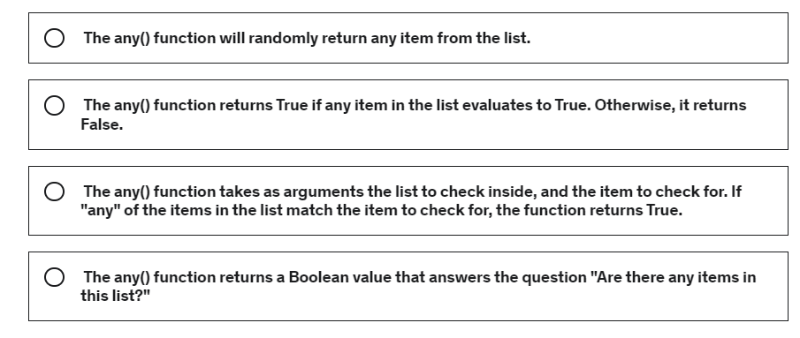

**Question 3**

**What statement about static methods is true?**

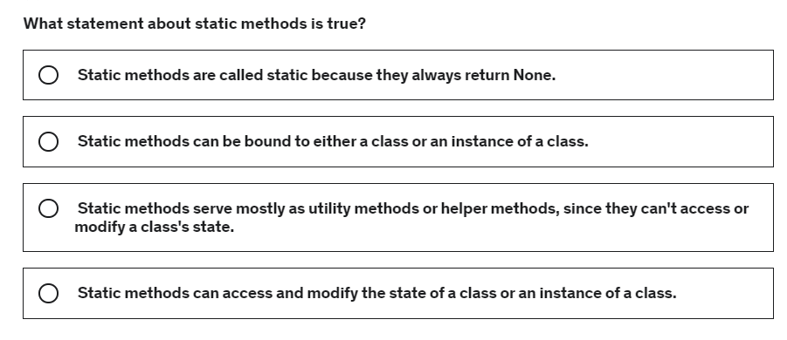

**Question 4**

**What are attributes?**

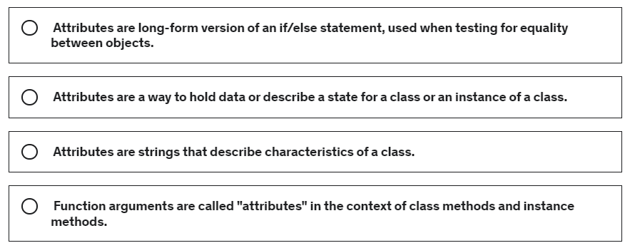

**Question 5**

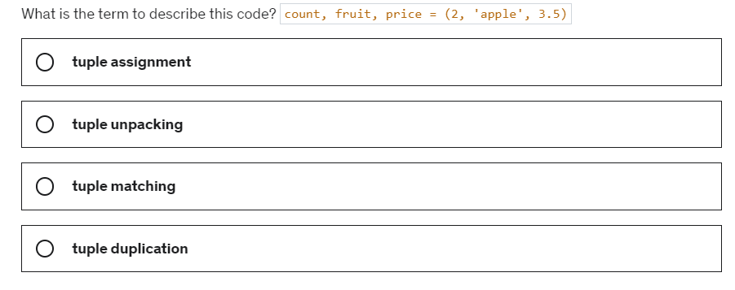

**Question 6**

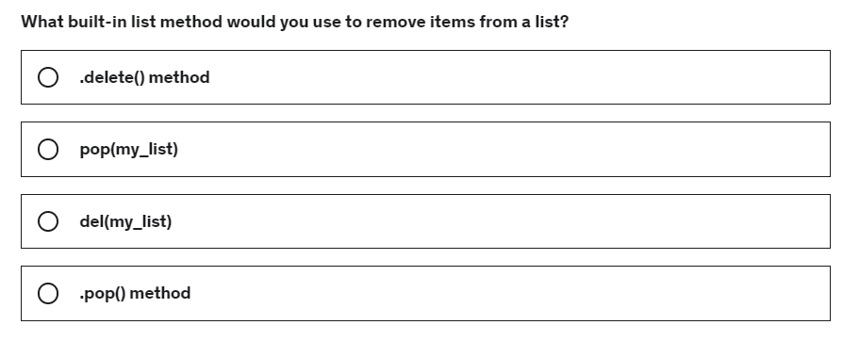

**Question 7**

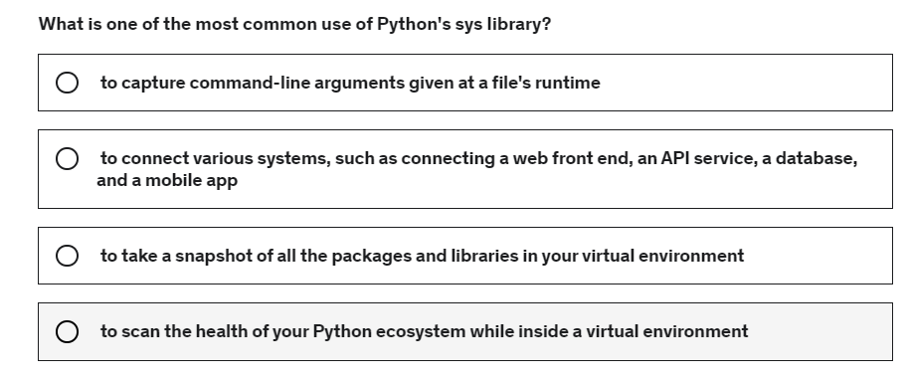

**Question 8**

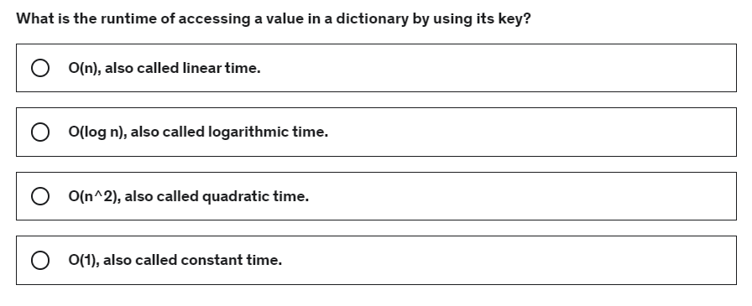

**Question 9**

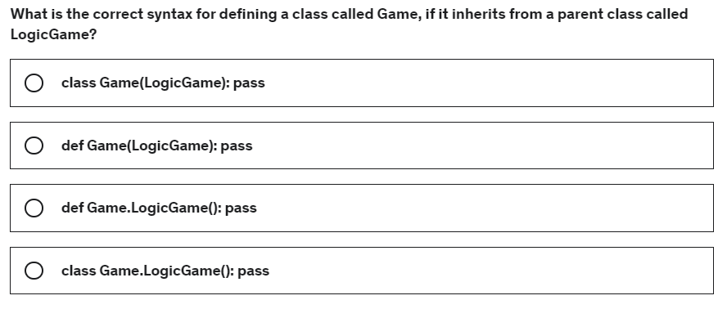

**Question 10**

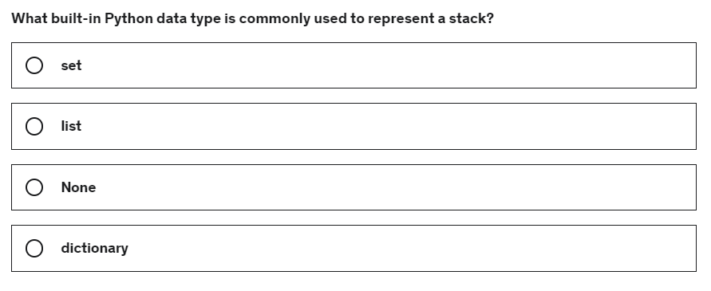

**Question 11**

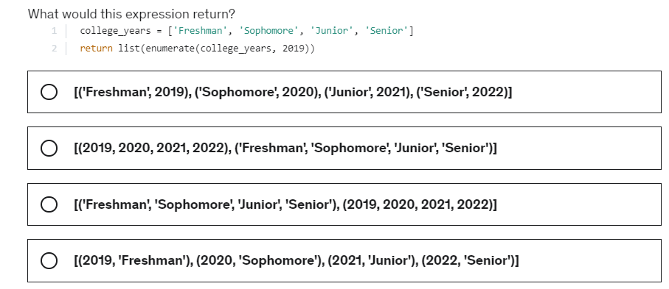

**Question 12**

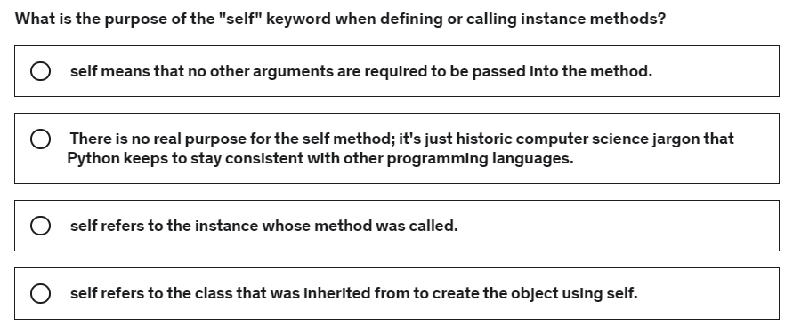

**Question 13**

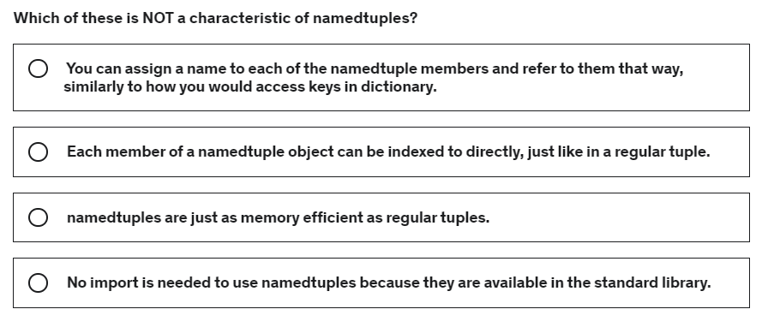

**Question 14**

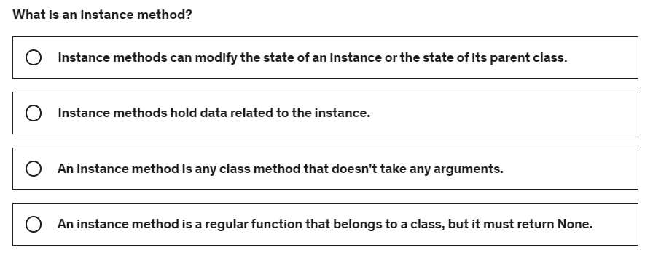

**Question 15**

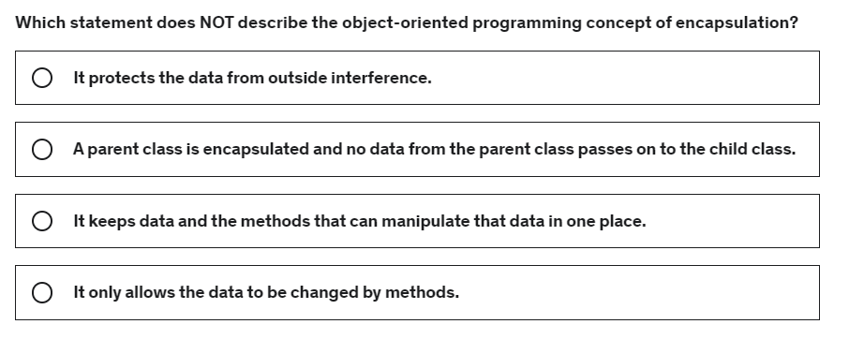

**Question 16**

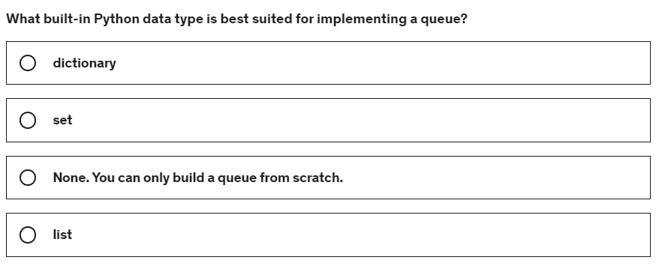

**Question 17**

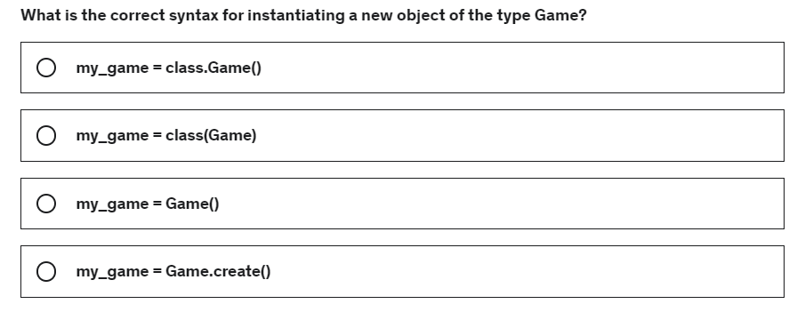

**Question 18**

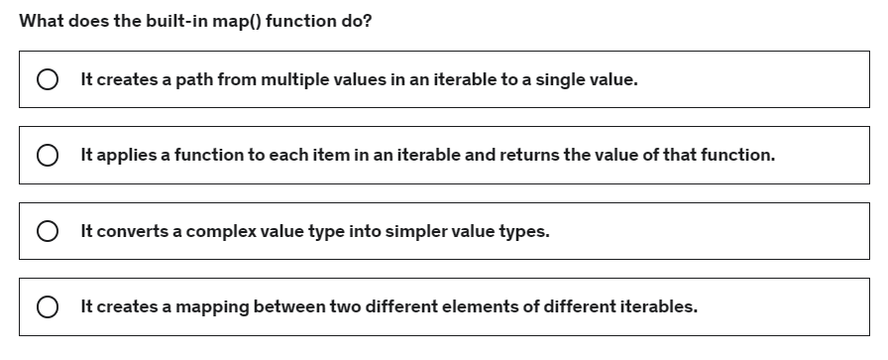

**Question 19**

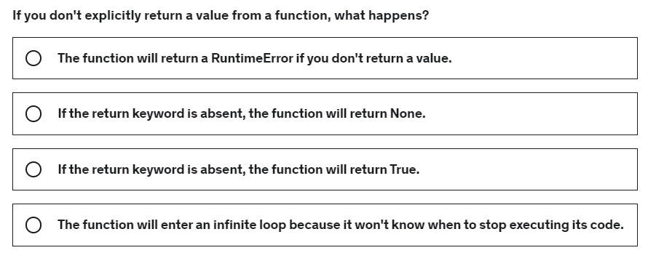

**Question 20**

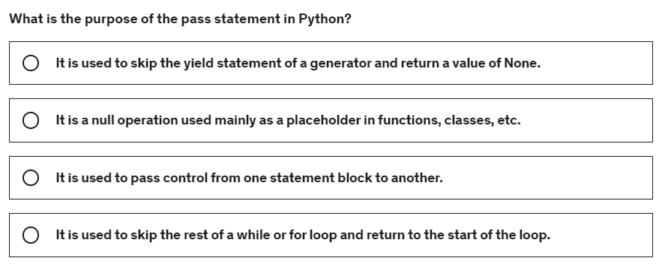

**Question 21**

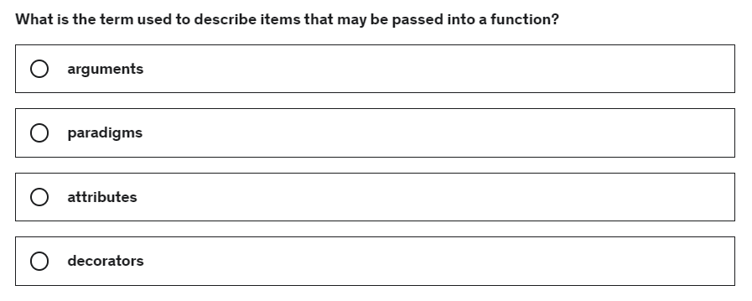

**Question 22**

Implement a function called maximum() that returns the maximum of three numbers. Use conditional statement.

Example

[IN]: maximum(4, 2, 1)

[OUT]: 4

**Question 23**

Implement a function called multi(), which accepts an iterable object (list, tuple) as an argument and returns the product of all elements of this iterable object.

Example

1. [IN]: multi((-4, 6, 2))
2. [OUT]: -48

**Question 24**

Implement a function map_longest() that accepts the list of words and return the length of the longest word in this list.

1. [IN]: map_longest(['python', 'sql'])
2. [OUT]: 6

**Question 25**

Implement a function called filter_ge_6() that takes a list of words and returns list of words with the length greater than or equal to 6 characters.

1. [IN]: filter_ge_6(['programming', 'python', 'java', 'sql'])
2. [OUT]: ['programming', 'python']
3. [IN]: filter_ge_6(['java', 'sql'])
4. [OUT]: []

**Question 26**

Implement a function called factorial() that calculates the factorial for a given number.

1. [IN]: factorial(6)
2. [OUT]: 720

**Question 27**

Implement a function count_str(), which returns the number of str objects in an iterable object (list, tuple, set).

1. [IN]: count_str(['p', 2, 4.3, None])
2. [OUT]: 1

**Question 28**

Implement a function count_str(), which returns the number of str objects with a length more than 2 characters from an iterable object (list, tuple, set).

1. [IN]: count_str([1, '#hello', '', 'python', 'go'])
2. [OUT]: 2

**Question 29**

The following list is given:

items = [(3, 4), (2, 5), (1, 4), (6, 1)]

Sort the list by the growing sum of squares of numbers in each tuple. Use the sort() method and the lambda expression and print sorted list to the console.

**Expected result:**

[(1, 4), (3, 4), (2, 5), (6, 1)]

**Question 30**

The present value - pv and the investment period - n are given below:

1. pv = 1000
2. n = 10

Depending on the interest rates given below, calculate the future value fv of your investment:

1. rate = [0.01, 0.02, 0.03, 0.04, 0.05, 0.06, 0.07]

Round the result to the full cent and print the result to the console.

**Expected result:**

1. [1104.62, 1218.99, 1343.92, 1480.24, 1628.89, 1790.85, 1967.15]